

**Training Report**

**OF**

**SIX MONTHS INDUSTRIAL TRAINING, UNDERTAKEN**

**AT**

**SUN PHARMACEUTICAL INDUSTRIES PRIVATE LIMITED**

**IN**

**IT DEPARTMENT**

**ON**

**“DATA BACKUP INVENTORY MANAGEMENT SYSTEM”**

**SUBMITTED IN PARTIAL FULFILLMENT OF THE DEGREE**

**OF**

**BE (CSE)**

**Under The guidance of: Submitted By:**

**Name: Mr. Deepak Mehta Name: Tarandeep Singh**

**Designation: University ID: 1411981247**

**Department: IT**

**Acknowledgement**

It is my pleasure to be indebted to various people who directly or indirectly contributed in the development of those who influenced my thinking, behavior and acts during the course of study.

I express my sincere gratitude to all for providing me an opportunity to undergo the Industry Oriented Hands on Training (IOHE) in Sun Pharmaceutical Industries Private Limited, Mohali.

I am thankful to “Mr. Deepak Mehta” for his support, cooperation, motivation and constant guidance provided during the training for constant inspiration, presence and blessings.

I also extend my sincere appreciation to my fellow teammates for their cooperation, our brainstorming sessions and sharing of knowledge in this project.

Lastly, I would like to thank my parents for their moral support.

**CERTIFICATE**

I hereby declare that the project work titled, **“Data Backup Inventory Management System”** submitted as part of Bachelor’s degree in Computer Science, at Chitkara University, Himachal Pradesh, is an authentic record of our own work carried out under the supervision of Mr. Deepak Mehta.Gayatri Guddad

mRm

**Date: Verified by: Mr. Deepak Mehta**Gayatri Guddad

mRm

Name:

**Tarandeep Singh**

**(1411981247)**

**Signature of Supervisor:**

**PREFACE**

My project “Data Backup Inventory Management System” is innovated to make a working webapplication on a project in order to create an e-Information about the backup. Through this application the person who is having the privileges can upload the location of the backup tapes and can send back the tapes to the required location. Moreover the admin can add different users and can provide them with the different privileges to use the website. The user with the privileges can add multiple backup of the tapes. This web application is made with the help of ASP.NET, HTML, CSS, JAVASCRIPT and MS SQL SERVER.

**Table of Contents**

**1.** **Introduction****................................................................................................................ 7**

1.1 Purpose........................................................................................................... 7

* 1. Objectives........................................................................................................ 7

**2.** **System Overview****........................................................................................................ 8**

2.1 Background…………………………………………………………………………. 8

2.2 Expected Business Related Benefits…………….………………………………. 8

**3.** **Scope****….……………………………………………………………………………………... 8**

3.1 Assumptions………………………………………………………………………... 8

3.2 Exclusions…………………………………………………………………………... 8

* 1. Limitations………...………………………………………………………………... 8

**4.** **Introduction to Assigned Job****…………………………………………………………… 9**

4.1 Scope……………………………………………………………………………….. 9

4.2 Individual Job……………………………………………………………………… 10

**5.** **Feasibility Study****………………………………………………………………………….. 11**

5.1 Technical Feasibility……………………………………………………………… 12

5.2 Economical Feasibility…………………………………………………………… 13

5.3 Behavioral Feasibility…………………………………………………………….. 14

5.4 Project……………………………………………………………………………... 15

**6.** **Requirement Analysis****…………………………………………………………………… 16**

6.1 Functional Requirements………………………………………………………… 17

6.2 Non-Functional Requirements………………………………………………….. 17

6.3 Technology Used…………………………………………………………………. 18

**7.** **DBIMS Operating Procedure****…………………………………………………………… 19**

7.1 Add Backup……………………………………………………………………….. 19

7.2 Add Multiple Backup……………………………………………………………… 20

7.3 Available Backup Summary……………………………………………………... 22

7.4 Daily/Monthly Backup Summary………………………………………………… 23

7.5 Search Backup……………………………………………………………………. 24

7.6 Send Backup……………………………………………………………………… 26

7.7 Send/Receive Backup Summary……………………………………………….. 27

7.8 Report……………………………………………………………………………… 29

7.9 Manage Users….…………………………………………………………………. 29

**8.** **Future Enhancements****………………………………………………………………….... 32**

**9.** **Conclusion****………………………………………………………………………………… 33**

**10.** **Bibliography and References****…………………………………………………………. 34**

1. **Introd****uction**

**1.1 Purpose**

The ***Data Backup Inventory Management System*** project is programmed in order to help the company in seeking backup tapes at a particular location. This project is designed in such a way that it keeps detailed information as well as separate information of all the locations from where the data is arriving and where it is stored.

The ***Data Backup Inventory Management System*** stores the information about the backup tapes more precisely we can say it store the information of the different systems at a particular location. It helps us in recovering of data according to the requirement by the employee.

The system is basically an E-information system for storing the precise location of the backup tapes.

**1.2 Objectives**

The objective of this UPM is to describe in detail the system operations for ***Data Backup Inventory Management System.***

1. **Syste****m Overview**

**2.1 Background**

The ***Data Backup Inventory Management System,*** system is an in-house system developed by Information Technology department at ***Mohali*** located in ***Punjab.***

It is designed to perform the following business functions:

1. To bring in an E-Information System to keep the backup tapes for all locations.
2. To store the precise location of the backup tape.
3. To maintain the record of send/received and available tapes.

**2.2 Expected Business-Related Benefits**

The system is expected to provide the following business-related benefits:

1. DBIMS shall ensure faster search and easy tracking of all the backup tape records.
2. DBIMS shall help to generate the summary of the available tapes in a location on various basis.
3. **Sc****ope**

**3.1 Assumptions**

The following assumptions are applied to this project:

1. The user will precisely store the location of the backup tapes.
2. The selected users involved in requirement session are representative of the department, which will be using the system.

**3.2 Exceptions**

There are currently no exclusions identified for this project.

**3.3 Limitations**

The following limitations are applied to the project:

1. The user will be provided with the privileges as per the requirement.
2. Only registered user can make changes in the database.
3. The rights would be available with the administrator of the project.
4. **Introduction** **To Assigned Job**

**2.2 Scope**

* **Existing System**

In existing Data Backup Inventory Management System, not all users can get access to the information because of the low working of the application or is not able to access any site. Sometimes the information is not updated or available for a particular place. In existing system the security is less and latest updates and uploads are not so frequent.

* **Proposed System**

In the proposed Blood Donation Management System, in this software once the timer is being arranged, it put up updates and uploads automatically and does not need anyone to do so. Also it is easily available due to its speed and programming part and using it is quite an easy task and well as due to its speed the information which will be available by one or two clicks, will get available in few seconds only.

**2.3 Individual Job**

As a fresher firstly they gave me an external training by an internal trainer on **ASP.NET**, **HTML, CSS, JAVASCRIPT, MS SQL SERVER** also they taught us **Manual TESTING** and this training was 3 months. After that they deployed us on the testing of the existing website, and we were guided to enhance the existing project by adding various new functionalities.

1. **Feasi****bility Study**

Feasibility study is the process of determination of whether or not a project is worth doing. Feasibility studies are undertaken within tight time constraints and normally culminate in a written and oral feasibility report. The contents and recommendations of this feasibility study helped us as a sound basis for deciding how to precede the project. It helped in taking decisions such as which software to use, hardware combinations, etc. The following is the process diagram for feasibility analysis. In the diagram, the feasibility analysis starts with the user set of requirements. With this, the existing system is also observed. The next step is to check for the deficiencies in the existing system. By evaluating the above points, a fresh idea is conceived to define and quantify the required goals. Besides that, a set of alternatives and their feasibility is also considered incise of any failure in the proposed system. Thus, feasibility study is an important part in software development.

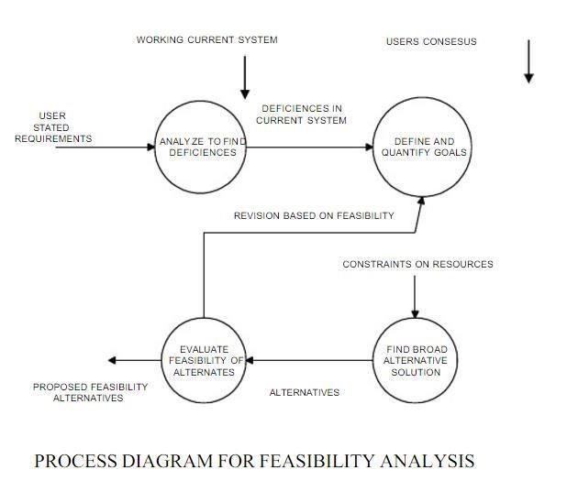

In the SDLC (Systems Development Life Cycle) of our project we maintained a number of feasibility checkpoints between the two phases of the SDLC. These checkpoints indicate that the management decision to be made after a phase is complete. The feasibility checkpoints in our project were as follows:

* Survey phase checkpoint
* Study phase checkpoint
* Selection phase checkpoint
* Acquisition phase checkpoint
* Design phase checkpoint

**5.1 Technical Feasibility**

Technical feasibility determines whether the work for the project can be done with the existing equipment, software technology and available personnel. Technical feasibility is concerned with specifying equipment and software that will satisfy the user requirement. This project is feasible on technical remarks also, as the proposed system is more beneficiary in terms of having a sound proof system with new technical components installed on the system. The proposed system can run on any machines supporting Windows and Internet services and works on the best software and hardware that had been used while designing the system so it would be feasible in all technical terms of feasibility. The technologies such as ASP.NET, JavaScript are compatible.

H/W’s are so familiar with the today’sknowledge based industry that anyone can easily becompatible to the proposed environment.

**Technical Feasibility Addresses Three Major Issues:**

* **Is the proposed Technology or Solution Practical?**

The technologies used are matured enough so that they can be applied to our problems. The practicality of the solution we have developed is proved with theuse of the technologies we have chosen. The technologies such as ASP.NET, JavaScript and **the compatible H/W’s are so familiar with the today’s** knowledge based industry that anyone can easily be compatible to the proposed environment.

* **Do we currently possess the necessary technology?**

We first make sure that whether the required technologies are available to us or nor. If they are available, then we must ask if we have the capacity. For instance,Will our current Printer be able to handle the new reports and forms required of a new system?

* **Do we possess the necessary Technical Expertise and is the Schedule reasonable?**

This consideration of technical feasibility is often forgotten during Feasibility analysis. We may have the technology, but that doesn’t mean we have the skills required to properly apply that technology. As far as our project is concerned we have the necessary expertise so that the proposed solution can be made feasible.

**5.2 Economical Feasibility**

Economic feasibility determines whether there are sufficient benefits increasing to make the cost acceptable, or is the cost of the system too high. As this signifies cost benefit analysis and savings. On the behalf of the cost-benefit analysis, the proposed system is feasible and is economical regarding its pre-assumed cost for making a system.

During the economical feasibility test we maintained the balance between the Operational and Economical feasibilities, as the two were the conflicting. For example, the solution that provides the best operational impact for the end-users may also be the most expensive and, therefore, the least economically feasible.

We classified the costs of Online job portal according to the phase in which they occur. As we know that the system development costs are usually one-time costs that will not recur after the project has been completed.

For calculating the Development costs, we evaluated certain cost categories viz.

* Personnel costs
* Computer usage
* Training
* Supply and equipment’s costs
* Cost of any new computer equipment’s and software.

In order to test whether the Proposed System is cost-effective or not we evaluated it through three techniques viz.

* Payback analysis
* Return on Investment
* Net Present value
* Cost-based study

It is important to identify cost and benefit factors, which can be categorized as follows: 1. Development costs; and 2. Operating costs. This is an analysis of the costs to be incurred in the system and the benefits derivable out of the system.

* Time-based study

This is an analysis of the time required to achieve a return on investments. The future value of a project is also a factor.

**5.3 Behavioral feasibility**

People are inherently resistant to change and computers have been known to facilitate change. There is always some reluctance among the users against the introduction of new system but they were told that this system would eliminate the unnecessary overhead of database migration

and conversion, which presently had to be carried out on daily basis to facilitate transactions between the different departments. The objective this feasibility phase is to take the operational staff into confidence. As the success of a good system depends upon the willingness of the operating staff, they were taken into full confidence that the new proposed system would make their jobs easier, relieve them from the unnecessary overheads and reduce the possibility of errors creeping into the system.

**5.4 Project**

The Data Backup Inventory Management System is to create an e-Information about the backup tapes stored in the location. Through this application we can easily track a tape that where it is stored, from which location it is, when the tape has arrived, from which courier it has arrived, etc. Moreover if we want to add an employee who can make changes and perform various functions on the database we have to contact to the administrator as the administrator can provide different privileges to the user.

Data Backup Inventory Management System project is aimed to developing an online Backup Tapes Information. The entire Data Backup Inventory Management System project has been developed keeping in view of the distributed client server computing technology, in mind.

Through this application we can easily track a tape that where it is stored, from which location it is, when the tape has arrived, from which courier it has arrived, etc. Moreover if we want to add an employee who can make changes and perform various functions on the database we have to contact to the administrator as the administrator can provide different privileges to the user.

Data Backup Inventory Management System project is designed such that it follows the view of distributed architecture having centralized storage of the database part. By using the constructs of MS-SQL Server and all the user interfaces have been designed using the ASP.NET technologies. The database connectivity is planned using the “SQL Connection” methodology. The standards of security and data protective mechanism havebeen given a big choice for proper usage. The application takes care of different modules and their associated reports, which are produced as per the applicable strategies and standards that are put forwarded by the administrative staff.

1. **Requireme****nt Analysis**

Systems analysis is the study of sets of interacting entities, including computer systems analysis. This field is closely related to operations research. It is also "an explicit formal Inquiry carried out to help someone (referred to as the decision maker) identify a better course of action and make a better decision than he might otherwise have made. “Analysis is defined as the procedure by which we break down an intellectual or substantial whole into parts so that we can achieve our end goals. The development of a computer-based information system includes a systems analysis phase which produces or enhances the data model which itself is a precursor to creating or enhancing a database. There are a number of different approaches to system analysis. When a computer-based information system is developed, systems analysis would constitute the following:

**Steps:**

1. The development of a feasibility study, involving determining whether a project is economically, socially, technologically and organizationally feasible.
2. Conducting fact-finding measures, designed to ascertain the requirements of the system’s end-users. These typically span interviews, questionnaires, or visualobservations of work on the existing system.
3. Gauging how the end-users would operate the system (in terms of general experience in using computer hardware or software), what the system would be used for etc.

Another view outlines a phased approach to the process. This approach breaks systems analysis into 5 phases:

* Scope definition
* Problem analysis
* Requirements analysis
* Logical design
* Decision analysis

Use caseare a widely-used systems analysis modelling tool for identifying and expressing thefunctional requirements of a system. Each use case is a business scenario or event for which the system must provide a defined response. Use cases evolved out of object-oriented analysis.

**6.1 Requirement specification**

Information gathering is usually the first phase of the software development project. The purpose of this phase is to identify and document the exact requirements for the system. The **user‘s** request identifies the need for a new information system and on investigation re-defined the new problem to be based on MIS, which supports management. The objective is to determine whether the request is valid and feasible before recommendation is made to build a new or existing manual system continues.

The major steps are:

* Defining the user requirements.
* Studying the present system to verify the problem.
* Defining the performance expected by the candidate to use requirements.

**6.2 S/W and H/W Requirement Specification:**

**6.2.1 Hardware Requirements:**

* Pentium IV 1.8 GHz and Above
* 128 MB DDRAM or More
* 40 GB HDD
* Printer
* Power Backup
* Internet Connection

**6.2.2 Software Requirements:**

1. Visual Studio 2014
2. Database
3. Web Server
4. Operating System

* Windows 7 /8 /10

**6.3 Technologies User**

**1. Presentation Layer**

* Web Interface
* HTML (Hypertext Markup Language).
* CSS (Cascading Style Sheet).
* JavaScript.

**2. Database Layer**

* MS SQL SERVER.

1. **DBIMS Ope****rating Procedure**

**7.1 Add Backup**

The user can add the backup tapes under the Add Backup Option.

1. 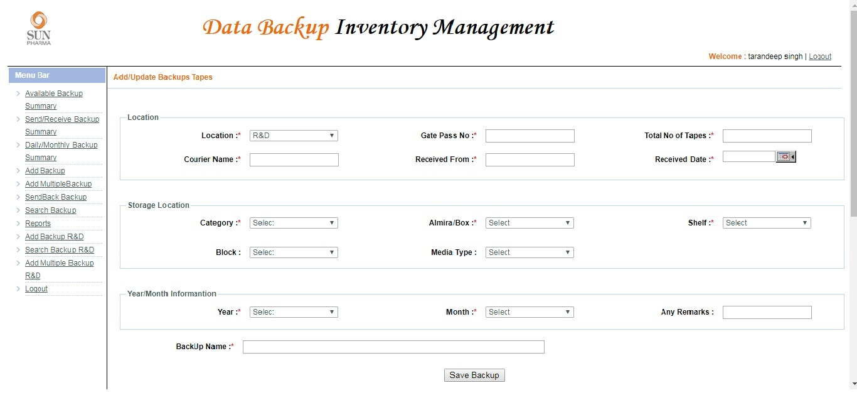Click Add Backup.
2. Fill in the following fields for adding the backup.

* Location: It is a dropdown showing the different locations of the company
* Gate Pass No: this is a textbox in which Gate pass number is stored which is issued at the time when the parcel is received at the gate.
* Total Number of Tapes: This is the textbox which stores the number of tapes arrived.
* Courier Name: This is a textbox in which courier name is stored i.e. from which courier company the tapes are sent.
* Received From: This is a textbox storing the name of the person who has received the tapes.
* Received Date: this is a text box which stores on which date the tapes are received.
* Category: It is a dropdown which shows the category in which you are storing the tapes i.e. it is a box, Almira or rack.
* Rack: It is a dropdown which displays different Rack numbers. Select the Rack in which you want to store the tape.
* Shelf: It is a dropdown which displays different Shelf numbers on the Rack. Select the shelf in which you want to store the tape.
* Box: It is a dropdown which displays different Box numbers on a shelf in the Rack. Select the Box in which you want to store the tape.
* Media Type: It is a dropdown which tells about the backup tape whether it is a CD, DVD or a HDD and etc.
* Year: It is a textbox which stores the year of the backup tape.
* Month: It is a textbox which stores the month of the backup tape.
* Remarks: It is a textbox in which the user can enter any remarks which would help the other user at any time.
* Backup Name: It is a textbox which stores the name of the Backup Tape.

1. Click on “Add Backup” button to add the data in the database. Once the User click on this button the request will be viewed in the grid-view as below.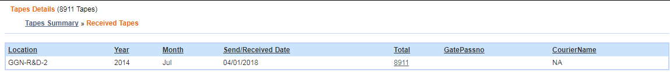

**7.2 Add Multiple Backup**

The user can add multiple backup tapes at a time by filling the following details and by uploading the excel sheet with the various details.

The user can add the backup tapes under the Add Multiple Backup Option.

1. Click Add Backup.

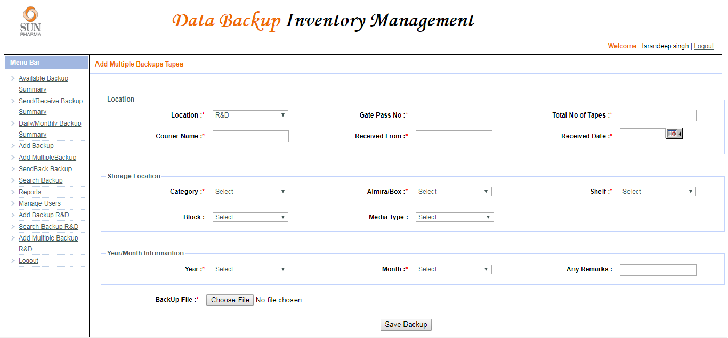

1. Fill in the following fields for adding the backup.

* Location: It is a dropdown showing the different locations of the company
* Gate Pass No: this is a textbox in which Gate pass number is stored which is issued at the time when the parcel is received at the gate.
* Total Number of Tapes: This is the textbox which stores the number of tapes arrived.
* Courier Name: This is a textbox in which courier name is stored i.e. from which courier company the tapes are sent.
* Received From: This is a textbox storing the name of the person who has received the tapes.
* Received Date: this is a text box which stores on which date the tapes are received.
* Category: It is a dropdown which shows the category in which you are storing the tapes i.e. it is a box, Almira or rack.
* Rack: It is a dropdown which displays different Rack numbers. Select the Rack in which you want to store the tape.
* Shelf: It is a dropdown which displays different Shelf numbers on the Rack. Select the shelf in which you want to store the tape.
* Box: It is a dropdown which displays different Box numbers on a shelf in the Rack. Select the Box in which you want to store the tape.
* Media Type: It is a dropdown which tells about the backup tape whether it is a CD, DVD or a HDD and etc.
* Year: It is a textbox which stores the year of the backup tape.
* Month: It is a textbox which stores the month of the backup tape
* Remarks: It is a textbox in which the user can enter any remarks which would help the other user at any time.
* Backup File: It is a File-Chooser which lets the user choose the file from the system which has the details of the Backup tapes.

1. Click on “Add Backup” button to add the data in the database. Once the User click on this button the request will be viewed in the grid-view as below.



**7.3 Available Backup Summary**

The user is provided with various options which are listed below:

* The user can check the number of tapes available in a particular year.
* The user can check the number of tapes available in a particular month.

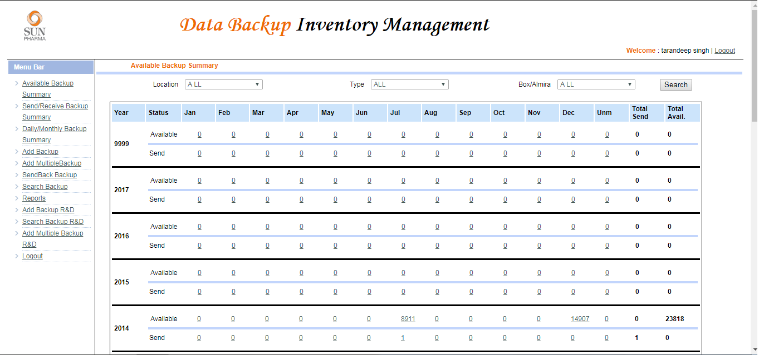

**7.4 Daily/Monthly Backup Summary**

It shows the number of available backup tapes. The user can check the entries in various options:

* The user can check the number of tapes available daily, weekly, monthly and yearly.
* The user is provided with a dropdown box for the search option as the user can select the location of the plant for which the available number of tapes would be shown as a result.

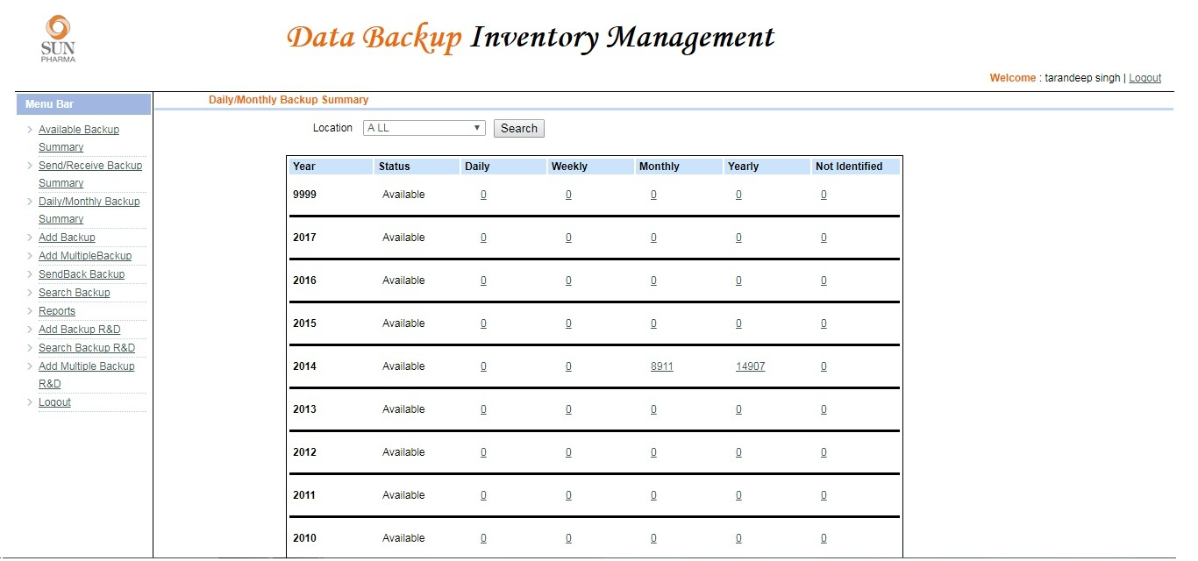

**7.5 Search Backup**

1. Search for the backup tape by selecting the various search options as below.

* Location- Select the location.
* Year- Select the year.
* Month- Select the month.
* Category- Select the category.
* Block- Select the block.
* Almira- Select the Almira.
* Shelf- Select the shelf.
* Backup Type- Select the Backup Type.
* Media Type- Select the media type.
* Backup Name- Write the backup name if any.
* Gate Pass- Select the Gate Pass number.

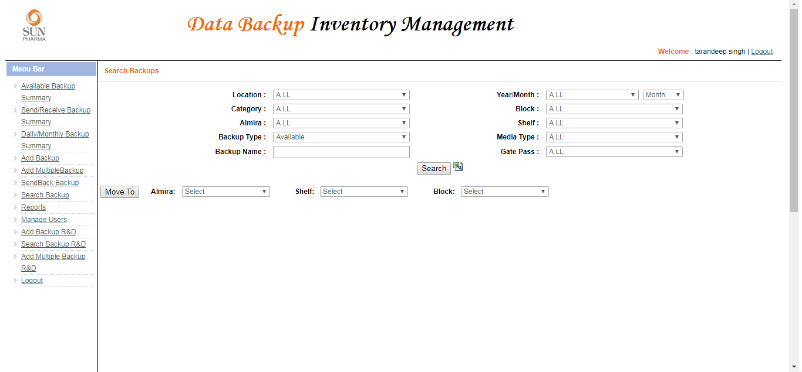

1. The user can change the storage location of the tape by using the move to option after searching the tape.

* Search the tape to be reallocated.
* Select the tape by clicking on the checkbox,
* Then select the Almira 🡪 Shelf 🡪 Block 🡪 Click on Move to.



**7.6 Send Backup**

The User can send back the backup on requirement by the following process:

1. Search for the backup tape by selecting the various search options as below.

* Location- Select the location.
* Year- Select the year.
* Month- Select the month.
* Category- Select the category.
* Block- Select the block.
* Almira- Select the Almira.
* Shelf- Select the shelf.
* Backup Type- Select the Backup Type.
* Media Type- Select the media type.
* Backup Name- Write the backup name if any.
* Gate Pass- Select the Gate Pass number.

1. The user can send the backup after searching the tape.

* Search the tape to be send back.
* Select the tape by clicking on the checkbox,
* The user can send multiple backup by selecting multiple checkboxes.
* Then select the Date 🡪 Gate Pass No. 🡪 Courier Name.

1. Click on Send Back.

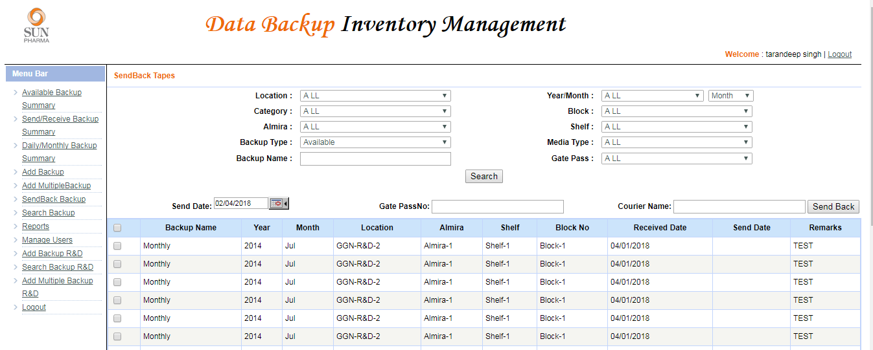

**7.7 Send/Receive Backup Summary**

The user is provided with various options which are listed below:

* The user can check the number of tapes received in a particular year.
* The user can check the number of tapes send in a particular year.
* The user can check the number of tapes received in a particular month of the year.
* The user can check the number of tapes send in a particular month of the year.

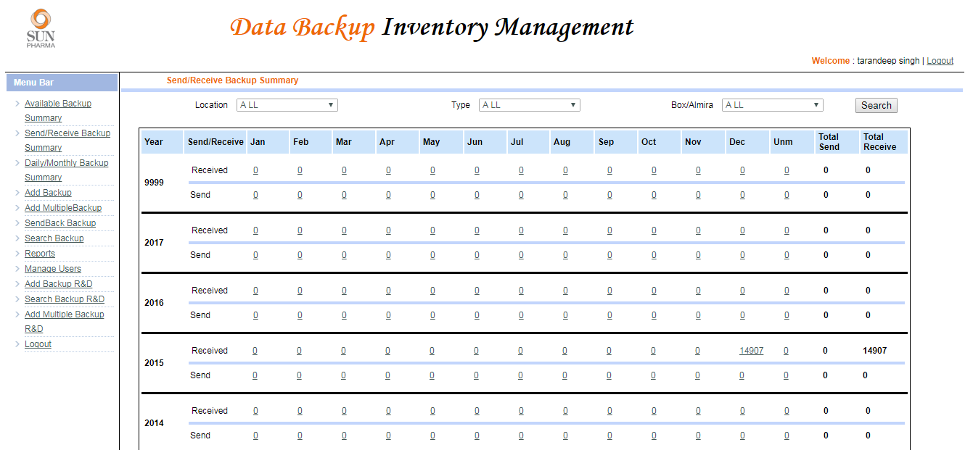

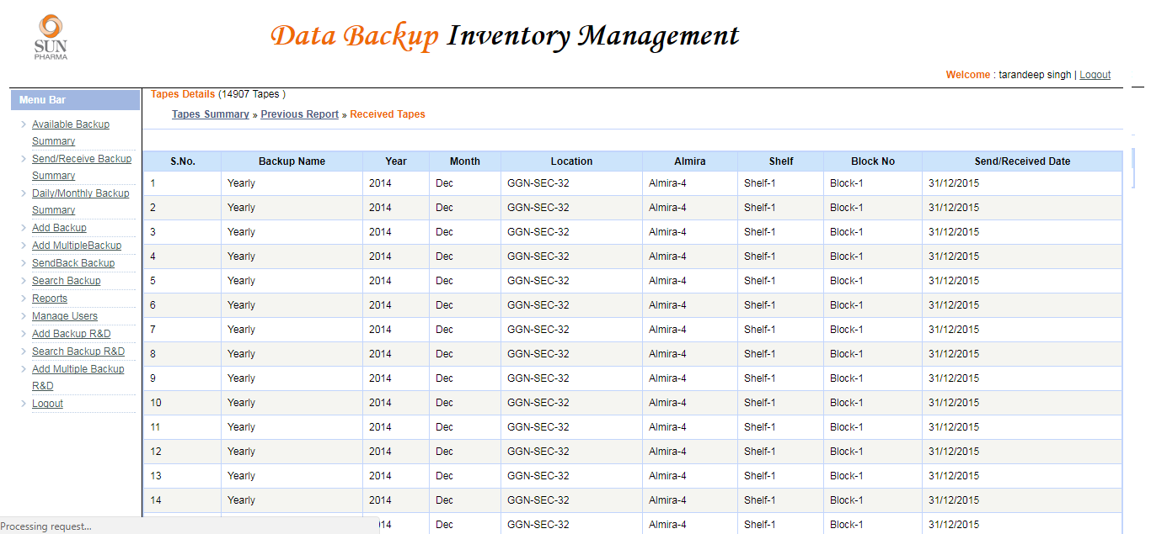

**7.8 Report**

The user can download the report of the following:

* [Backup Log (Out) Report](http://moh-srv-12/Reports/Pages/Report.aspx?ItemPath=%2fBackup+Management%2fOut+Backup+Report_GatePassWise).
* [Backup Log (In) Report](http://moh-srv-12/Reports/Pages/Report.aspx?ItemPath=%2fBackup+Management%2fIn+Backup+Report_GatePassWise).
* [Year/Location wise Monthly Summary](http://moh-srv-12/Reports/Pages/Report.aspx?ItemPath=%2fBackup+Management%2fYearwise_Locationwise_Monthwise_Summary).
* [Location/Year wise Summary Matrix](http://moh-srv-12/Reports/Pages/Report.aspx?ItemPath=%2fBackup+Management%2fLocationwise_Yearwise_SummaryMatrix).

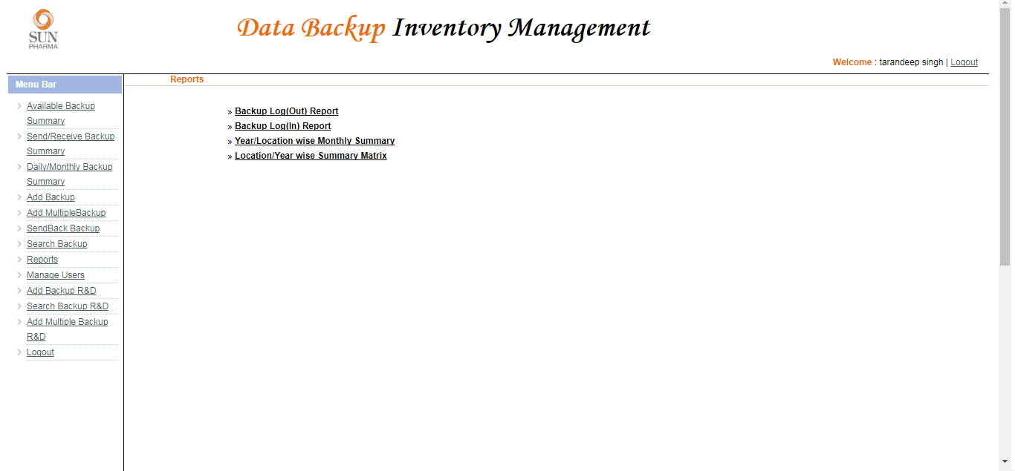

**7.9 Manage Users**

The admin can add new users and grant them various privileges as per the requirement.

1. Make the users Active or Inactive

* Select the user by clicking on the check box in front of the user name.
* Click on Active or Inactive.

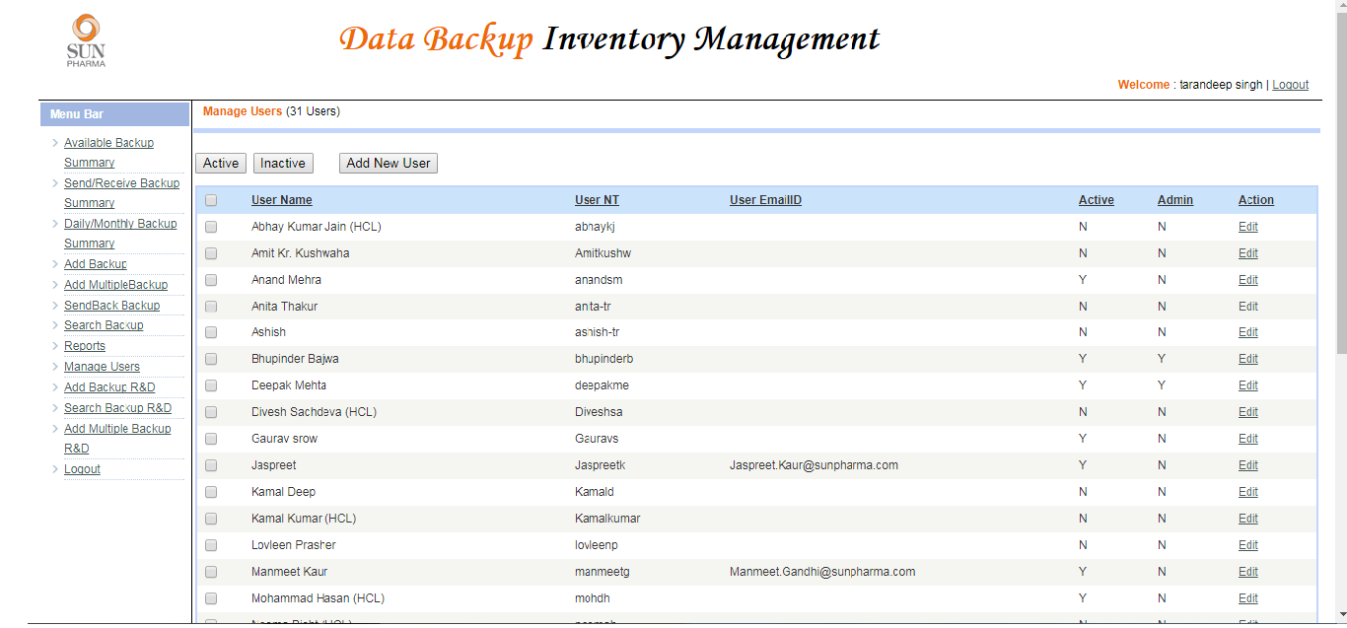

1. The admin can add new user and provide the user with different privileges through which the user can perform the following functions. To add a new user:

Click on add new user.

Fill the following details to add a User:

* User Name.
* User NT.
* Email of the User.
* Active or Inactive.
* Below are the permissions that can be granted to the user:

1. Available Backup Summary.
2. Send/Receive Backup Summary
3. Daily/Monthly Backup Summary.
4. Add Backup.
5. Add Multiple Backup.
6. Send Back Backup.
7. Search Backup.
8. Reports.
9. Manage Users.
10. Click on the Submit button to add the new user.

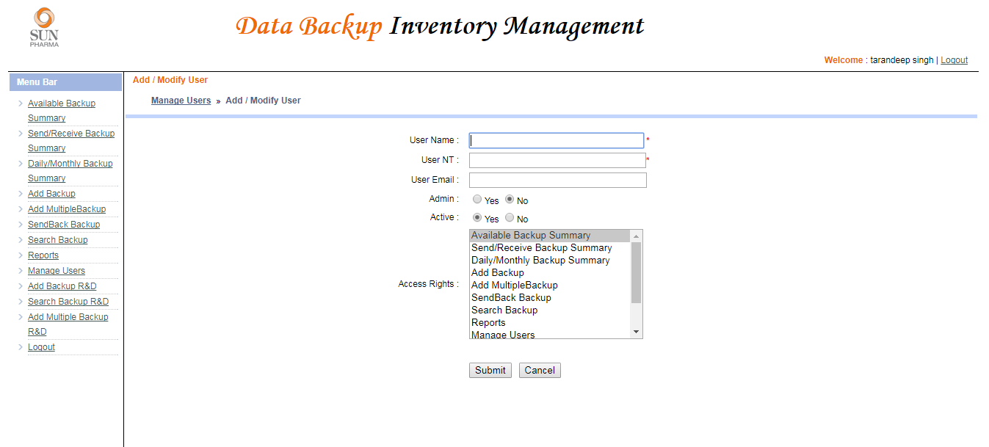

1. **Future Enhan****cements**
2. **Con****clusions**

**10. Bibliogra****phy and References**